Comments on differences between packing coefficients calculated with Platon and with CCDC programme
CCDC programme can have any grid spacing you specify – the finer it is the more accurate the calculation. Platon uses a grid of 0.2. This enables Platon to potentially run faster than using Aurora’s suggested 0.1 grid spacing.
Platon does not work on structures where Z=16. It works for 8 * 42 atoms (KONTIQ_1_C1C1_3, Z’=2) but not for 16 * 21 atoms (KONTIQ_10_Conf1_A1).
Platon does not work on the NIWFEE structures, which are the only ones from my set in Pna21.
Platon does not work on P21/n structures, which it thinks are P-1 structures (so halves the density and packing coefficient).
Platon does not work on old DMAREL atom labels (eg CAR1).
The CCDC programme works from the SFAC line, so this needs to be correct (some of our old searches are not).
Platon does not work on files copied from Windows all the time (run dos2unix and it is fine).
Plotting the Platon Packing Coefficient against the CCDC Packing Coefficient (with 0.2 grid spacing) gives the plot below. The single structure that is more than 0.02 different is tetrachlorobenzene.
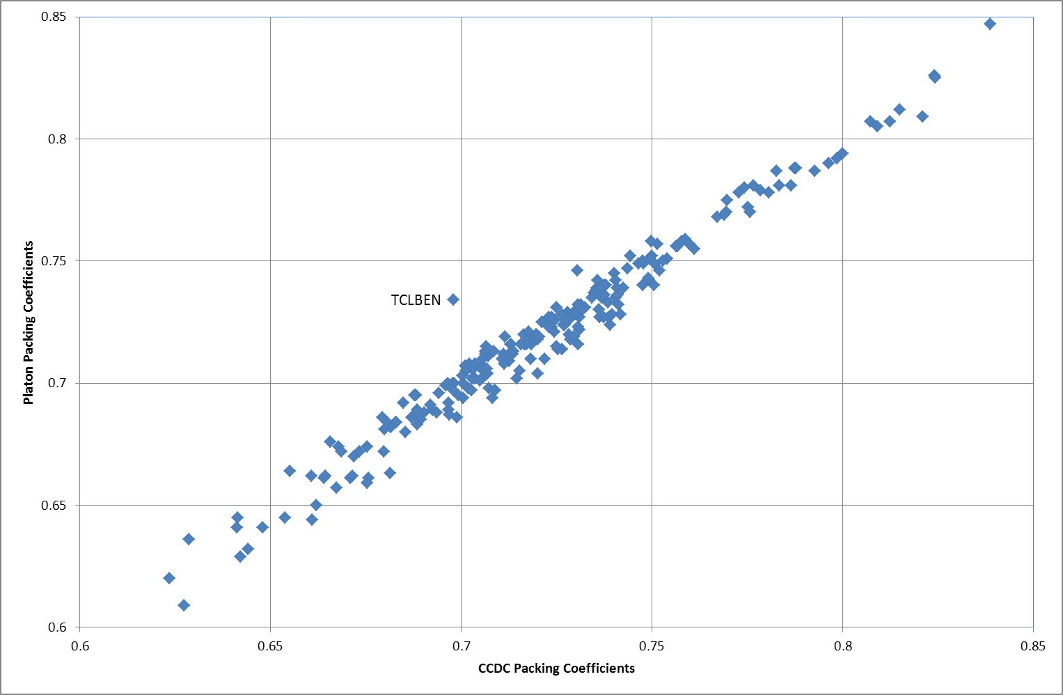
A full set of structures (Olanzapine following CrystalPredictor, DMAflex-Quick, CrystalOptimizer, PCM; Study_ID=20) was put through packing coefficient calculation with both platon and the CCDC tool. This gave the correlation seen below.
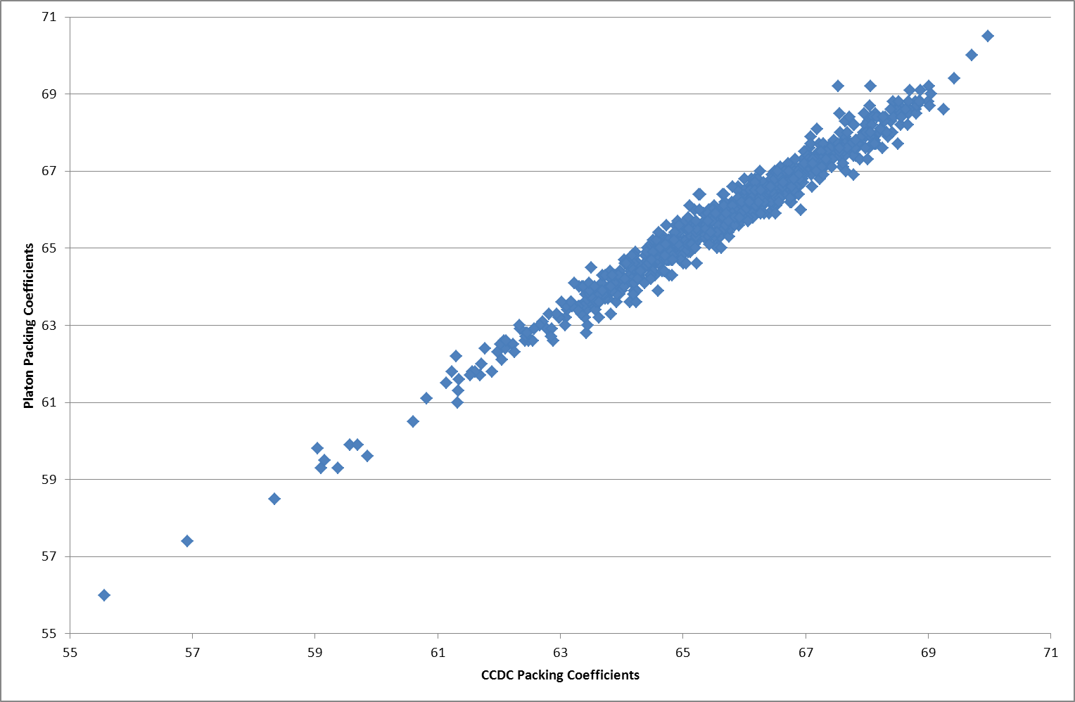
Platon could not calculate a packing coefficient at all for structures in Pna21, Ia and Ic. Platon calculated a value that was ca. 50% of the value calculated by the CCDC tool for structures in P21/n and I2. Platon calculated a value sometimes, but not other times, and it was wrong when it did, for structures in I2/a and I2/c.
For the full set, density against packing coefficient is plotted below (eq and red; ax are blue).
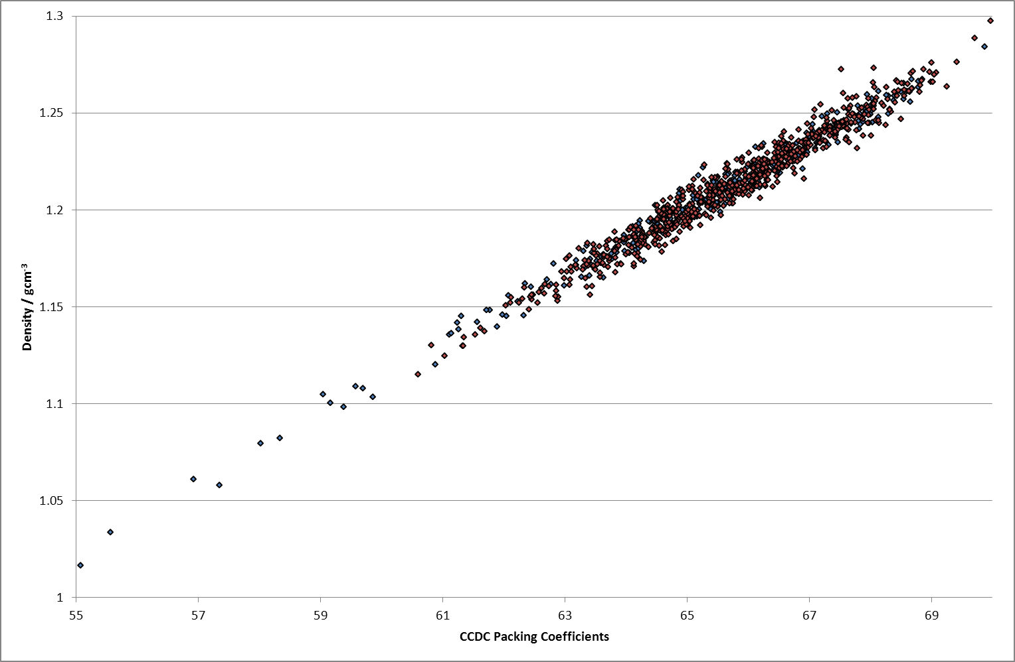
Three different representations of the lattice energy landscape are given below.
