 | A (kJ/mol) | B (1/Å) | C (kJ/mol Å^6)
N…N | 1123827 | 3.98 | 1604.1
Cl…N | 2339577 | 4.00 | 3335.6
Cl…Cl | 3789880 | 3.98 | 7063.1
Cc…N | 597599 | 3.88 | 1625.0
Cn…N | 532334 | 4.01 | 1625.0
Cl…Cc | 1467509 | 3.88 | 3415.5
Cl…Cn | 1288322 | 3.99 | 3415.5
Cc…Cc | 477635 | 4.64 | 1656.6
Cn…Cn | 316662 | 4.17 | 1656.6
Cc…Cn | 366071 | 4.46 | 1656.6
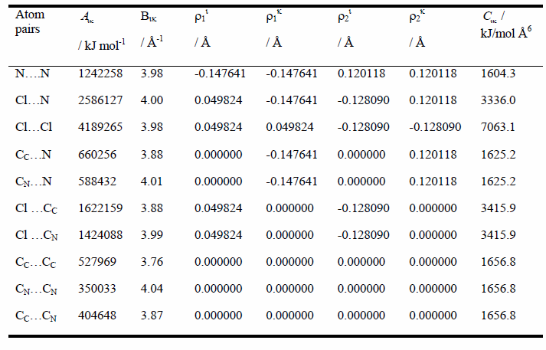
Table of parameters provided by David Bowskill Feb 2018, converting archived input files into kJ/mol using a conversion of 96.485 kJ/mol to 1 eV. Changes in conversion factors account for the variation in Cικ, relative to the ESI table below. However, the differences in the Bικ values for the C…C parameters probably mean that the Table in the ESI corresponded to a different model than that used to generate the results, with different Aικ values for many interactions. Since David Bowskill was able to reproduce published results much better with the parameters above than with the published parameters, we apologise for the error in the publication.

